
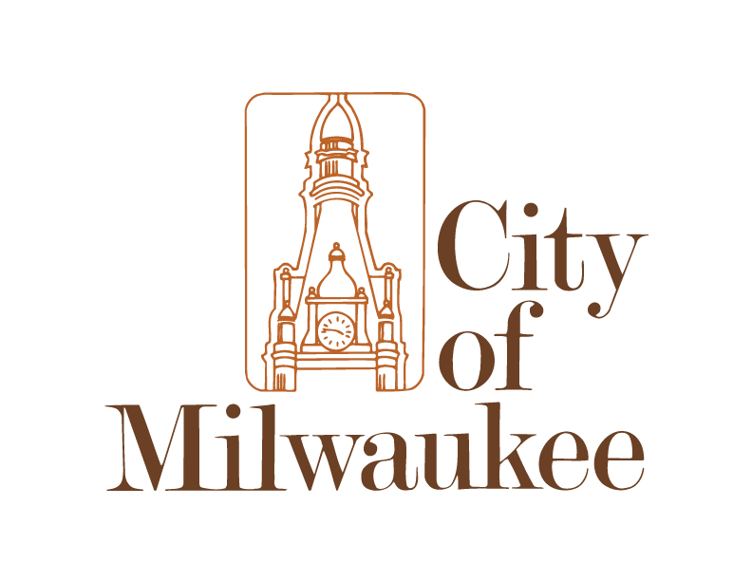

CURRENT JOB OPENINGS
Department of Employee Relations – Staffing Services, City Hall – Room 706, 200 E. Wells St.
as of 8/26/2026 9:38 AM

For the job descriptions, salaries, minimum education and experience requirements of the positions listed below, and to apply, go to www.milwaukee.gov/JOBS.
Applications are accepted online only and must be submitted by 11:59 p.m. on the posted deadline.
COMMUNITY HEALTH DIETITIAN 1 (MHD) – CONTINUOUS
Under the direction of the WIC Program Manager, the Community Health Dietitian 1 provides nutrition and administrative services for the City of Milwaukee Health Department’s (MHD) Women, Infants, and Children (WIC) special supplemental nutrition program and serves as a lead worker for Community Health Nutritionists, WIC Client Services Assistants, and Breastfeeding Peer Counselors.
COMMUNITY WELLNESS AND SAFETY DEPUTY DIRECTOR (DCWS) – 08.31.2026
The Community Wellness and Safety Deputy Director works closely with City leadership, community partners, and other stakeholders to advance departmental priorities and provides executive leadership in support of DCWS’s citywide violence prevention and community wellness mission.
ENGINEERING TECHNICIAN II AND IV (MWW) – CONTINUOUS
The Engineering Technicians II and IV conduct water main replacement, water distribution system repair, and lead service line replacement inspections to ensure compliance with and enforcement of Milwaukee Water Works (MWW) specifications.
ENGINEERING TECHNICIAN IV (MWW) – CONTINUOUS
The Engineering Technician IV conducts water main replacement, water distribution system repair, and lead service line replacement inspections to ensure compliance with and enforcement of Milwaukee Water Works (MWW) specifications.
ENGINEERING TECHNICIAN IV (DPW) – 08.28.2026
The Engineering Technician IV leads a survey crew in conducting surveys for improvement projects and related studies.
EQUIPMENT OPERATOR 1 (DPW) – CONTINUOUS
The Equipment Operator 1 performs professional driving and critical manual labor functions, including municipal solid waste and recycling collection, street sweeping, snow and ice control, and operation of heavy equipment for the Department of Public Works. This position is critical to the cleanliness, health and safety of the City, its residents and visitors.
INDUSTRIAL MACHINE REPAIR MECHANIC 3,4, AND REPAIRPERSON 5 (DPW) – CONTINUOUS
Industrial Machine Repair Mechanics and Repairpersons perform preventative maintenance on and repairs to Milwaukee Water Works (MWW) equipment and facilities, operate snow and ice control equipment, and perform routine duties at outlying booster stations.
INDUSTRIAL MACHINE REPAIRPERSON 5 (DPW) – CONTINUOUS
Industrial Machine Repairpersons 5 perform preventative maintenance on and repairs to Milwaukee Water Works (MWW) equipment and facilities, operate snow and ice control equipment, and perform routine duties at outlying booster stations.
LIBRARY CIRCULATION SERVICES RPRESENTATIVE – BILINGUAL (MPL) – 09.01.2026
The Library Circulation Service Representative- Bilingual performs a variety of duties related to circulating physical library materials and providing patron services.
The Library Circulation Services Representative-Bilingual provides translation and interpretation services in Spanish and English.

LIBRARY PUBLIC SERVICES AREA MANAGER (MPL) – 09.04.2026
The Library Public Services Area Manager (PSAM) oversees the Special Collections and Humanities division, including the Krug Rare Books Room and archival collections. The PSAM manages unit goals, priorities, and work plans aligned with the Library’s mission and strategic direction.
POLICE OFFICER (MPD) – CONTINUOUS
Police Officers preserve public peace, protect life and property, work within the community to prevent crime, and enforce ordinances of the City of Milwaukee and the laws of the State of Wisconsin.
PUBLIC HEALTH NURSE 1 (MHD) – 08.28.2026
City of Milwaukee Public Health Nurses engage in a variety of population-based and individual nursing activities in homes, schools, clinics and community settings, designed to assure that health care is accessible and available to residents.
PUBLIC HEALTH NURSE 2 AND 3 (MHD) – CONTINUOUS
Public Health Nurses engage in a variety of population-based and individual nursing activities in homes, schools, clinics and community settings designed to assure that health care is accessible and available to residents.
VEHICLE SERVICES TECHNICIAN 3 (DPW) – 08.28.2026
Vehicle Services Technicians inspect, maintain, and repair operating systems of various automobiles, light trucks, vans, heavy trucks, and equipment.

How to learn about City of Milwaukee employment opportunities:
INTERNET: | www.milwaukee.gov/jobs
E-MAIL: | www.milwaukee.gov/enotifyjobs  Subscribers receive an e-mail when a new job announcement is posted (includes Fire and Police).
PHONE: | (414) 286-5555 (24-hour recording – updated as needed)
IN PERSON: | Job announcements are posted on a bulletin board outside of Room 706 in City Hall. However, applications are accepted online only. Office hours are weekdays; 8:00 a.m. – 4:45 p.m.
Other employment opportunities:
- School Crossing Guard: For an application call the Milwaukee Police Department at (414) 935-7995.
- Election Workers: For an application go to: www.milwaukee.gov/election
- Housing Authority: https://www.hacm.org/about-us/human-resources/hacm-careers
- Compete Milwaukee, Transitional Jobs Program: call UMOS at (414) 389-6000 or for more information go to https://city.milwaukee.gov/dpw/AdministrativeServices/Compete-Milwaukee

