ALL INCLUSIVE PAYROLL INSTRUCTION - REV 09/2026

Welcome! This manual will give you an overview of what Payroll Administration, Comptroller’s Office, needs from you to get employees paid, what your responsibilities as payroll assistants and/or managers may be, how to enter and adjust time, and other various procedural items.
As an aside, this manual will not teach you about HCM (aka People Soft) Job Data Entries and similar categories. DER has separate instruction for payroll personnel. Please visit DER pay service’s website for instruction on job data entries and the like.
This packet is arranged to work electronically. Ctrl+Click on a subject below and the document will navigate there. Also embedded are links to important websites and documents. All links should work when on a network computer.
- How payroll flows through the system and the pay period schedule
- Citytime
- Timecards access
- Timecard Self-Training
- Entering time and attendance, Templates, Reports, and Correcting timecards
- Adjustments and Access
- New Employees, Employee Self-Service, Terminated Employees and 112R’s
- Taxes (W-2 and W-4)
- Direct Deposit
- Direct Deposit Statements and Check Stubs
- Social Security Cards and Names
- Jury Duty
- Military
- Address Changes
- Garnishments, Child Support or Tax Levies
- Death of an active employee
- Paid Time Off, the Time Owed and Allowed Report, and Employee Self Service Leave Balances
- Payroll Register
- Detail Dollars and Hours
- Auto Allowance
- Commuting Mileage
- Sick Leave Control Incentive Program (SLCIP)
- Pension
- Donor Pay
- Pay Run ID
- Advances
- Overpayments / Underpayments
- Overtime
- NDB (Non-Discretionary Bonus)
- Clearing your cache
- Where to find things and Conclusion

- How payroll flows through the system and the pay period schedule

All pay entries start in Citytime or an Excel special pay sheet. Citytime holds all employees’ timecards and most adjustments. This data gets "loaded" to HCM (aka People Soft). Payroll Administration completes the processing. The completed payroll then gets posted to FMIS and distributed to other entities like Deferred Comp, the banks for direct deposits, and ERS.
FMIS
Citytime-Timecards

HCM
Citytime-Adjustments
Other Entities
Excel Special Pay Sheet (Adjustments)

Pay Period (PP) Schedule is always 2 weeks:
This week is called edit week in these instructions
FIRST SUNDAY OF A PAY PERIOD | MONDAY | TIMECARDS FROM PREVIOUS PP DUE @ 3:30PM*  112R FROM PREVIOUS PAY PERIOD DUE @ NOON*  TUESDAY | PAY ADMIN PROCESSING-ONLY NEW HIRES MAY BE ENTERED. NO OTHER CHANGES TO HCM ARE ALLOWED**  WEDNESDAY | PAY ADMIN PROCESSING-ONLY NEW HIRES MAY BE ENTERED. NO OTHER CHANGES TO HCM ARE ALLOWED**  THURSDAY | PAY ADMIN PROCESSING-NO CHANGES TO HRMS ARE ALLOWED**  SYSTEM MAY BE RELEASED BY NOON  FRIDAY | SATURDAY
 | DATA FROM PREVIOUS PP AVAILABLE IN HCM AND FMIS.  ENTER JOB DATA ENTRIES FOR CURRENT PP |  | DEFAULTS FROM PREVIOUS PAY PERIOD ARE AVAILABLE TO ADJUST | PAYDAY-PAYS PREVIOUS PAY PERIOD'S PAY  ADJUSTMENTS AND ALL ADJUSTMENT PAPERWORK FOR CURRENT PP DUE @ 11AM* | HCM JOB DATA ENTRIES FOR CURRENT PP DUE BY EOB | LAST SATURDAY OF A PAY PERIOD
This week is called payweek in these instructions

*May be changed due to holidays
**Unless specifically authorized by Payroll Administration

- Citytime

Citytime is programmically administered by ITMD. Citytime is installed on your desktop/laptop. If you experience a system outage or slowness, first thing you should do is log out of Cityime and then log back in. If that is not successful, then talk to your Department’s network administrator to see if there are problems with your Department’s network. Finally, if the above steps do not solve your problem, file a service desk plus request at www.milwaukee.gov/servicedesk

- Timecard Access

It is typically up to the Department’s Payroll Assistant or Manager to set up new users/employees for Timecard access. The instructions to set up new users are located in Citytime in the online help section
Click on “Adding New Users to Time Entry – Instructions”. Every Department should have one level 8 (payclerk) or 9 (manager) department administrator. Level 8 and 9 may set up level 7 and below. Level 7 or 9 must serve in a management capacity. Non-management personnel may be level 2-6 or 8. Any employee may be level 1. Most payclerks are level 6. Most managers are level 7. Best to set all your employees up as single user access so they have their balances of vacation and sick.
An employee must remain in the selected level for the whole pay period.

- Timecard self-training

Also located in the online help section is a “Training Participation Guide for Payroll Staff”. While the instructions are somewhat dated, they should give you further insight on how to navigate through Citytime, how to enter and edit timecards, and how to run reports.

- Entering time and attendance; templates, reports, and correcting

Entering time and Attendance (see picture below):
Choose a date within the pay period (PP) you are entering on the calendar Do note, if the calendar pop up is not available, click on the date line at the top of the page to restore the pop up calendar. Click on any month/date/year within the PP you want to enter. Assure the PP you are entering time for appears in the PP at the top of the page. If you are entering time for a terminated employee, choose a date on the calendar from when they were active.

Every active employee in HCM (see chapter one of DER’s Hire Workforce training participating guide) has a timecard in Citytime on the BiWeek Sheet tab. All Job Data like crewID, name, job code, “empl type”, flsa type, are originated in HCM. Through interface, HCM shares data with Citytime. Give the Citytime a whole day to refresh after an HCM change. HCM is the source for all personnel data, then shares it with Citytime, on a schedule.

Click on the dropdown for crewid. It should list all the crews you have access to, click on the one you want. Then

click on the dropdown for name. It should list all the employees assigned to that crewid. Choose the name of the employee you want to enter time and attendance for.

Note: If the “Empl Type” is hourly, all working and paid time off must be entered. If the “Empl Type” is exception, only paid time off is entered. Typically, if the “Empl Type” is exception, employees do not need to enter holidays as most exception employees follow the City holiday schedule.

All FLSA status labeled as non-exempt must be hourly for “Empl Type” (non-exempt means the employee is eligible for overtime). All FLSA status other than non-exempt that work under a grant must be hourly (ARPA excluded). FLSA status other than non-exempt typically means that are exempt from overtime (not eligible for overtime). If a timecard has entries, it must have a “manager” AND “pay clerk” approval by the timecard due date.
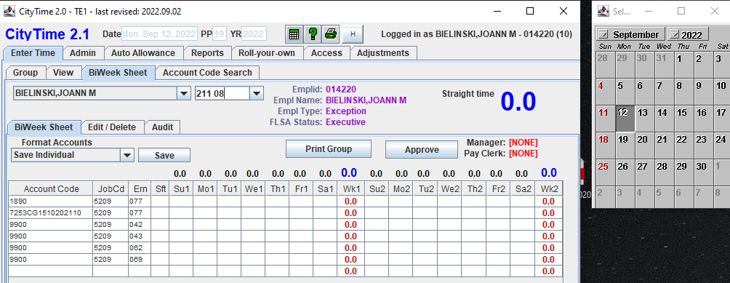

Note: “Pay clerks” must NOT log in as a “Manager” to approve timecards. This is a management duty that must NOT be delegated.

Entering time is data entry. Enter time (hours and minutes) in the applicable square in BiWeek Sheet and hit enter or tab. An eight-hour day will be entered as 8.0. A four and one half hour shift is entered as 4.5. The ”totals” in the upper right hand corner will increase as you enter time. To assure you have the right day, you can hover over the days of the week (for example hover over Su1 for first week of the Sunday through Saturday week) and Sunday’s date will appear. When time is complete, the manager and pay clerks will review and approve time by clicking on the approve box (approve box will populate the appropriate space, depending on log in credentials).
Templates:
You may find that employees use the same account codes and ern codes (earn codes) all the time. Templates may be set up for efficiency.
Step 1 – fill out the first three columns of the timecard with common account codes/ern codes. Assure the job code is the same as the HCM job code for the pay period you are entering. If a job code changes in HCM, you MUST update your template manually.
- See section for eligible earn codes (ern) .
- All paid time off, using earn codes like 042 (vacation), 043 (sick), etc. use account code 9900
- All working and overtime earn codes, like 077, etc. must use a valid account code. See the tab labeled Account Code Search next to the BiWeek Sheet (pictured at bottom of page). Please, be extra careful when using grant numbers in your templates. Once grants expire or run out of funding, they should be removed from your template.
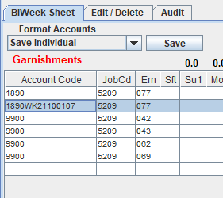
Step 2 – create your new template or save your changes by clicking on the dropdown, choose the action, and then click save. Note: it is an old system. You may have to save twice for it to take.
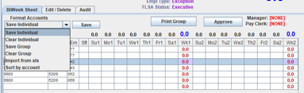

All eligible earn codes may be found on the Enter Time, Group tab. Click on a name to see all eligible earn codes. Then you may enter on the employee’s BiWeek sheet (you’ll have to go back to the BiWeek Sheet shown above). 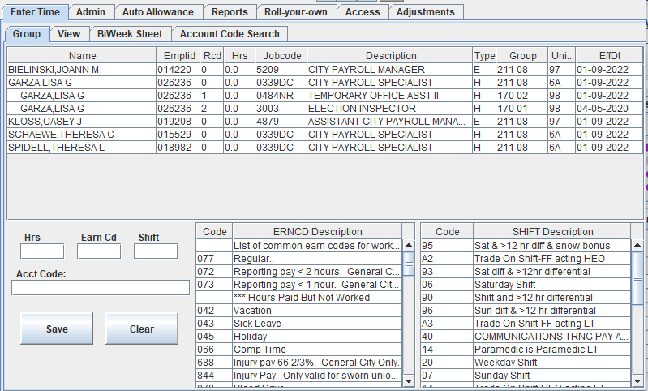

Reports:
It is important that all full time employees have 80 hours of paid time entered (336 for Fire). If they are not to be paid 80 (or 336 for Fire) hours, then an unpaid earn code should be used like “299” for FMLA unpaid, “MLP” for unpaid military, or “UPT” for unpaid time not related to FMLA or military leave. If an employee is unpaid, unrelated to FMLA, for one pay period or more, an HCM job data entry should be prepared. If an employee is suspended without pay, an HCM entry must be made, with no entries on the timecard. HCM entries or timecard entries communicate if an employee is unpaid. If employees are unpaid and Pay Admin does not see a termination row in HCM, a leave of absence in HCM, or an unpaid time code on the timecard, an e-mail should be sent to ptransmit@milwaukee.gov before timecards are due or we will contact you to assure mistakes are not made.

It is important for you to assure all timecards are entered timely and accurately. There are several reports every payroll assistant and/or manager should run before timecards are due. These are found in the dropdown on the Reports tab

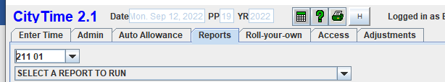

*Inactive Employees w/ time* – if data appears, delete all entries that appear on or after the Inactive date for the employee.
*Hrs reported but not approved* – Run this every timecard Tuesday until 3:00pm to assure all entries remain unchanged and approved.
*Active Hrly Empls with < 80 hrs/pp* – All employees should be paid 80 hours. If not paid 80 hours, it should be reviewed and documented either with unpaid earn codes, HCM job data entry, or an e-mail to pay adm (ptransmit@milwaukee.gov). Unpaid time affects BSD.
*Active hrly Empl with > 40 hours in a pp/week for hours worked* – if a Non exempt (eligible for overtime) employee works more than 40, then the 41st hour is overtime. Please record appropriately.
*Exempt empl > than 80 hours* – new – This report will show you all Exempt (not eligible for overtime) employees that claimed more than 80 hours on a timecard. It is prohibited. This report, when all is corrected, should report zero lines.
*Employees w/ >8 straight time hrs/day* – It is always advisable to do a review of those employees with greater than 8 hours in a day, especially those with > (greater than) 12 hours, a Non exempt might be eligible for additional shift pay.
*Exception pay >80 hours* – No exception (as opposed to hourly) employee may claim more than 80 hours on a timecard. Report should show 0 lines when all errors are resolved.
*Hours charged by earn code/date range* – It is pretty self-explanatory in the prompt. Try 069 to assure all employees that took 069 are eligible and not at the maximum allowed for the year, same with 062, 064-not allowed on timecards at all, PNW and TNW (always needs a reason to use), etc. You might have other earn codes you wish to explore for your department.
*Negative leave accruals for all groups* – keep an eye on negative balances. Vacation, should not be more than -80; all others categories, negatives are not allowed, review the timecard to assure time is not overpaid.

It is important for you to run these reports at the end of every pay cycle. It is especially important to run the *Hrs reported but not approved* report on Timecard Close Tuesday until at least 3:00pm.
Feel free to continue to use the reports that have served your department well, especially the FMLA and other reports. This is just a list of reports that are required to close payroll.
There are several reports to run. You should run all reports to discover what each report shows for your section. Every department follows ordinance or contracts, but every department has their own schedules, AWA arrangements, and practices. It is up to you to become familiar with offerings.
Each timecard should be reviewed against the paid time off available. Paid Time off is displayed at the bottom of an employee’s timecard on the BiWeek Sheet tab or on the TOA. If paid time off recorded on the timecard is more than available, management should be made aware and steps should be taken to assure paid time off is not overdrawn. Vacation is the only exception. Please review the DER policy on vacation in Policies. It is called “Vacation and Transitional Vacation Account (TVA) Guidelines”.

Correcting/Deleting Timecards before the Timecard Deadline:
Online corrections can only be made for the current pay period. Once the hours are passed to Payroll Administration, there can be no subsequent changes to those hours on the timecard. It is for this reason that payroll staff will need to ensure that all employee time has been reported before the deadline.
It is extremely important to remember that CHANGES CANNOT BE MADE DIRECTLY ON THE BIWEEK SHEET. All changes to hours previously recorded must be made on the 'Edit / Delete' panel located within the BiWeek Sheet tab.
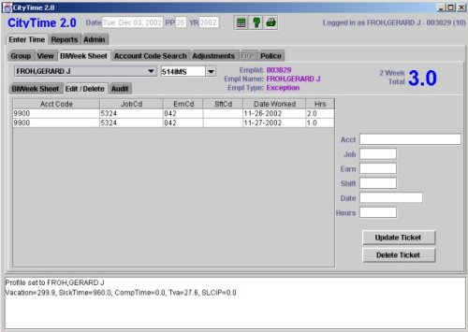
Fields on the right

To change an online time entry
- Step 1: Select the employee you want to edit by clicking their Crewid and name in the pulldown from the BiWeek Sheet.
- Step 2: Click on the Edit/Delete tab within the BiWeek screen.
- Step 3: Click on the entry line to be changed. Information about this specific ticket will fill the fields on the right.
- Step 4: Make any necessary corrections in the fields on the right and press the 'Update Ticket' button.
You will get a message telling you if the modification was successful or not.

To delete an online time entry
- Step 1: Select the employee you want to edit by clicking their Crewid and name in the pulldown from the BiWeek Sheet.
- Step 2: Click on the Edit/Delete tab within the BiWeek screen.
- Step 3: Click on the entry to be deleted. Information about this specific ticket will fill the fields on the right.
- Step 4: Press the 'Delete Ticket' button.
You will get a message telling you if the deletion was successful or not.

Whenever an entry is changed, the system records the User ID of the person making the change in an Audit Sheet. DON'T GIVE YOUR USER NAME AND PASSWORD TO ANYONE. If they make a change to someone's time in the system, it will have YOUR SIGNATURE on it. This audit ticket shows that Safiya Fore changed a ticket for Dec 02, 2002 from 8 hours to 4 hours. Similar audit records appear for deleted time.
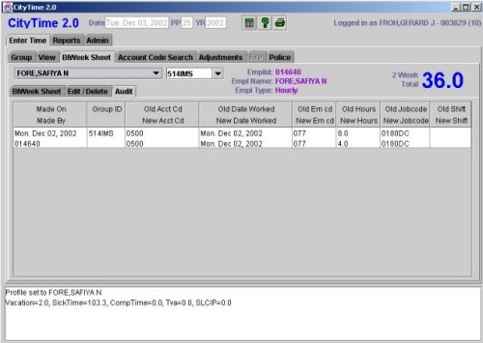

- Adjustments and access
While it is the goal of every payroll professional to get the payroll right the first time, it is realized that some circumstances are out of your control and we allow for adjustments to be made to the Time Owed and Allowed (TOA), Hours, and/or Dollars of most original accruals or other entries.
Adjustments can be made within Citytime adjustments or by Excel spreadsheet.
Citytime Adjustments is a custom front-end adjustment recording system that provides users with electronic access to Adjustments based on their authorized security level.
Payroll Administration sets up users for Adjustment access. The form may be found in the Payroll Administration website. The file is called “Access Form for Adjustments”. The form must be signed by a Department Head (or designee). The signed form may be scanned/e-mailed or interoffice mailed to Payroll Administration.
Adjustments are an extremely important part of the payroll process. Adjustments correct how time was recorded, pay employees special premiums, pay employees what is due upon termination, pay employees increases in wages, correct leave accrual balances, and also correct overpayments.

Separate instructions on how to do electronic Citytime adjustments may be found on the Payroll Administration website. The document is titled “City Time Adjustment Instr. Rev 8/24”.

Excel spreadsheets are meant for voluminous and repetitive entries. If you see a need for an adjustment to be submitted on an Excel spreadsheet, you may find the template on the Payroll Administration website. However, adjustments via special Excel spreadsheet MUST be approved by Pay Admin before submitting. Email PAY ADM at ptransmit@milwaukee.gov to request approval. If approved, completed Excel spreadsheets are to be submitted via e-mail to PAY ADM with a cc to a manager(s) acting as manager approval. When attaching the spreadsheet to the e-mail, include in the narrative the description of the adjustment you're submitting, the total dollar/hour amount and the number of data rows without the headers. If additional documentation is required, Payroll Administration will notify you. Excel spreadsheets will not be accepted for missed pay increments, retro promotions, or any other increase in base pay without prior approval from Payroll Administration.
3. New Employees, Employee Self-Service, 112R’s, and Terminated Employees

-New employees shall go to a NEO Benefits Monthly Webinar or www.enrollcityofmilwaukeebenefits.com
-New employees should also become familiar with DER policies and benefits pages
-Within a week of hire, new employees are granted access to employee self-service. All employees use self-service to enroll/change benefits, fill out W-4/WT-4, enroll in direct deposit, view their paychecks, view W-2’s, and apply for tuition reimbursement. Select departments have other modules within self-service. If employees experience trouble or need instructions, they should view the self-service instructions.
-Please encourage employees to consent to receiving electronic W-2’s. It is the safest and most efficient way to receive this year-end form. If processing goes well, oftentimes the W-2 may be viewed mid-January. If they do not consent, payroll administration postmarks the document on Jan 31.

- Payclerk or HR clerks should work off the Pay Clerk Checkoff New Empl Rev 4-19 to capture all steps to hire a new employee (a new version will be coming out soon – new version for new procedures to NEO and W-4/direct deposit electronic forms). Typically, payroll is told the compensation rate for new employees via an employee certification from DER; however, the salary ordinance should be consulted for additional pay details, like maximums, minimums, and especially footnotes. You may access the Salary Ordinance from the Department of Employee Relations /Compensation website.
Notes regarding the Salary Ordinance and HCM.
  - Those employees with an N (ie. 2DN) at the end of the Pay Range are non-exempt. They are eligible for overtime and must be hourly pay in the system. Those employees with an X (ie. 1FX) at the end of the Pay Range are exempt. They are not eligible for overtime. They may be hourly or exception pay in the system. Those exempt employees that claim their work under a grant should be hourly (except ARPA). To see this designation in HCM, go to Job Data/Job Information and click on the flag at the bottom of the page.
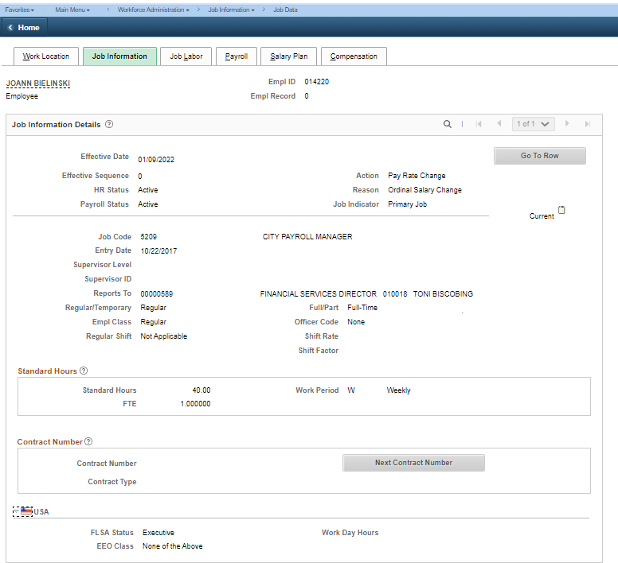
  - Every HR and Payroll Professional should be familiar with Part II of the Salary Ordinance. Please take some time to read it.
  - The migration of new Pay Ranges is incomplete in HCM. If you find a Pay Range in HCM that does not match Salary Ordinance, use this conversion document.

Payroll Deduction Authorization, Form 112R, is a form that is used to communicate changes in employee status, taxes, and deductions to Payroll Administration. Form 112R, Payroll Deduction Authorization (#35), may be accessed from Forms.
  - When an employee is new and does not use self-service to fill out his/her tax forms, then fill out a 112R and attach the federal and state tax forms.
  - An existing employee may have a change to taxes or certain deductions, send a 112R with new tax form, if he or she does not update taxes in self-service. Only X is needed in the W-4/WT-4 boxes. We are simply looking for a form if X’ed. Submit tax forms and 112R in a confidential envelope.
  - When an employee is terminated (retired/resigned/fired), indicate so on the 112R and tell us to stop all deductions.
  - Departments with sworn employees: Submit 112R for all sworn union changes as union dues and select deductions are affected.

Terminated employees typically have leave balances (vacation, TVA, comp, and maybe sick, aka terminal leave) that need to be bought out. Eligible retirements are entitled to terminal leave, vacation, TVA, SLCIP and compensatory time buyouts; also special payment buyouts as required by sworn union contracts. Resignations are entitled to vacation, TVA, SLCIP, and compensatory time buyouts; also special payment buyouts as required by sworn union contracts. Discharged employees are entitled to compensatory time buyouts and select special payment buyouts as required by sworn union contract. Final paychecks must be received by the employee 30 days after the last day at work. Negative balances must be adjusted as soon as employee or department announces termination. Typically, if an employee terminates on the last day of a pay period, all buyouts must be prepared in the next payroll. Chapter 350 dictates what time employees may be bought out for. Note: Discharged employees are not entitled to a vacation buyout.

The HCM entry for all terminations must occur immediately. All terminated employees must be made Hourly in the pay period of their termination. Terminated employees retain access to self-service indefinitely.

Termination due to death has its own rules.

4. Taxes - W-4/WT-4 Withholding and W-2 Reporting
W-4/WT-4
W-4 is the federal Employees Withholding Certificate form. WT-4 is the State of Wisconsin's form. Each form must be filled out and one may not substitute for the other.
Current tax forms may be found in Forms (#69 and #70). Assure the correct year is used for the federal form. It is up to payroll clerks to assure that the form is complete. Payroll Admin does not accept facsimiles, copies of forms, DocuSign, or forms with scribbles or white out. Paperclip the W-4 and WT-4 to the 112R and submit to Payroll Admin by 10AM on edit week Tuesday.
All paper tax forms received by Payroll Administration must be accompanied by a completed 112R Form. Do not advise employees to drop off forms directly at the Comptroller’s Office – they must be routed through departmental payroll clerks first.
Again, changes to Federal W-4 do not change the State WT-4 withholding. Both forms must be submitted to affect a change in both statuses.
The W-4 changed significantly from previous years. Assure Step 1 and 5 are complete. Steps 2, 3 and 4 are optional. No additional markings should appear on the front of the certificate. No payroll professional should be offering tax advice. You may tell them which sections are required, but do not offer tax advice. Invite the employees to read the instructions attached to each certificate. It is their responsibility to file their withholdings correctly. When in doubt, they should seek their own tax advice from a professional or IRS.gov.
Note: Employees claiming exemption from withholding must refile every year they are eligible. Those not refiling will automatically change to the highest legal withholding after April 30 for State and February 15 for federal. Again, this is stated in the instructions.
W-2

W-2 is the IRS Wage and Tax Statement. This form is required to be sent to every employee that earned wages from the City of Milwaukee every tax year. Payroll Administration prepares the statement, but it is expected that you will answer simple questions about it. On the Payroll Administration website is an explanation of W-2’s, under the memos section. The file is called “Form W-2 Wages and Tax Statement for 20xx”. Use it as your guide. Paper W-2’s must be postmarked by January 31st, however, let your employees know that an electronic version is available in self-service. They must consent to receive an electronic version in self-service. Here are the tiles in Self-Service:

 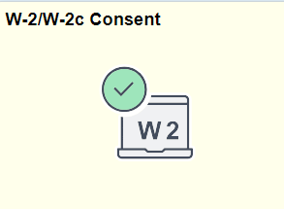 if it says consent received in the W-2/W-2c Consent tile, no other action is needed. Employee will receive the W-2/W-2c in self-service, not postal mail.

Click the box to get the electronic version. Click Submit. Tell employees that it is a win-win. They get their W-2’s sooner and safely, the City saves on postage and if they ever need a copy, it will always be free from self-service. Otherwise hard copies are $25.

Note: If employees experience problems printing/viewing their checks or W-2’s in self-service, likely it is due to pop-up blockers. Employees must turn off pop-up blockers while in self-service.

Hard-copy W-2’s are distributed by January 31 of the following year to an employee’s last known address. All terminations receive a paper copy. If employees do not receive or lost their W-2 and they don’t use self-service, then they must file Request for W-2 Form, C-403 (#68). Hard copy W-2’s for the immediate prior year are free until April 15, but the form must be filed. After April 15th, they must submit the form AND $25 (for up to 7 years of past W-2). Again, W-2’s are always free from self-service and need no form.

5. Direct Deposit

Direct deposit is mandatory for every employee. Direct deposit may be applied for using a paper application or self-service.
- All direct deposit paper applications (#10) must be completed, signed and be accompanied by a voided check (no starter checks) or a letter from the bank showing the employee’s name on the account, routing number, account number and type of account (checking or savings). All direct deposit applications come to Payroll Administration (Room 404 of City Hall). If all is received correctly, completely, and in time for payroll processing, the direct deposit should happen immediately. Note: All DD forms must have an employee ID. Employees MUST use the form dated Sep. 2018 with updated terms and conditions.

- Employees can also submit direct deposit elections via Self Service. Here are the instructions:
- Log into Self-Service. Click on the Payroll Tile, then Direct Deposit Tile.
- Click on the arrow. Read and agree to the terms the pop up.
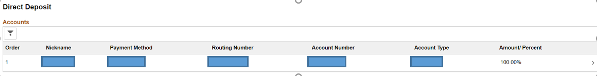

Then this appears.
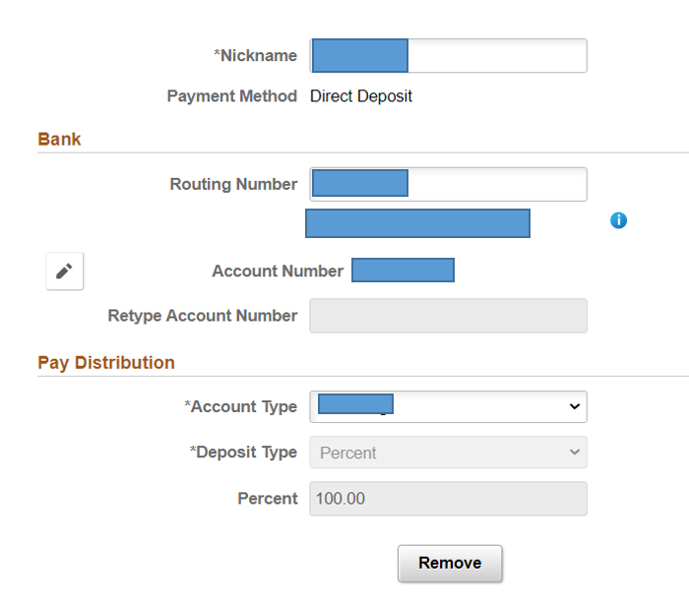

- Enter the Routing Number. If you don’t know which number is a routing number, click on the information button . The bank name should automatically populate upon entering. While Pay Admin and ITMD went through great lengths to assure all current banks are in the system, new banks and credit unions form all the time. Please contact us at ptransmit@milwaukee.gov if your routing number is unavailable. We can add it in house after a short routing number verification process.
- Enter your Account Number, twice. This assures that your funds will be deposited into the right account.
- Choose the Account Type. You may choose from Checking or Savings in the dropdown.
- Click Submit. If Submit is clicked prior to noon on edit week Thursday, your new account should be active for the next payday. The holidays may alter this schedule. **Remind employees to keep the old account open until they actually get a deposit in the new account.**

Employees may direct deposit 100% of their net pay to one account. Employees may not split their direct deposit to separate accounts. There are programs in place at Prime Financial Credit Union and the Brewery Credit Union that allow employees to pay a loan or deposit into a savings account directly from their check at the City if Milwaukee. Refer employees to those Credit Unions for details.
If an employee experiences fraud on his/her account, they should first speak with the bank. Most banks will open a new account for that employee and will do a courtesy transfer of their direct deposit for a limited time. It will be up to the employee to fill out a new direct deposit form/update self-service, asap, to change accounts. The courtesy transfer only last a couple of pay periods.
If an employee closes his/her account after Pay Admin is done processing payroll but before payday, the employee will have to wait until those funds are returned to the City by the bank. This happens at the EARLIEST on the Monday after payday. The Treasurer's Office will then issue a check to the employee.
Note: When employees terminate, tell them to leave their direct deposit account open. All final checks will be direct deposit.
If terminated employee is rehired, they should fill out a new direct deposit form/update self-service to assure their financial information is still valid. Pay Admin attempts to reach out to departments for rehires to see if accounts are still active, but will often inactive accounts for employees that were rehired after more than six months after their last active date.
6. Direct Deposit Statements and Check Stubs

Direct Deposit (aka Advices) statements should be reviewed by employees every pay period via self-service. In Self-service an employee may click on the payroll tile, then the paychecks tile. Pay stubs going back to 2000 are available.
Note: Individual payroll departments shall not print direct deposit statements. Pay professionals may do it on a case-by-case basis, like when employees request the stubs for proof in a court appearance or for a social service agency and cannot access stubs on a computer or mobile device.

Those employees receiving a paper check should be encouraged to participate in Direct Deposit every pay period. Participating in Direct Deposit is mandatory. Pay Admin will contact employees when in non-compliance.

All paper checks are mailed to an employee’s mailing address.

- Social Security Cards and Names

Every Department should have a copy of each employee's social security card on file. The name that appears on the Social Security card should be the same as in HCM. You should not be changing a name in HCM until a copy of the new Social Security card is received. Middle initials may be used for middle names. It is a good practice to update general comments for name changes.

- Jury Duty

The most common type of jury duty is Milwaukee County jury duty. However, this section applies to all jury duty, no matter where served. If an employee claims 8 hours of just duty on his/her timecard (earn code 046):
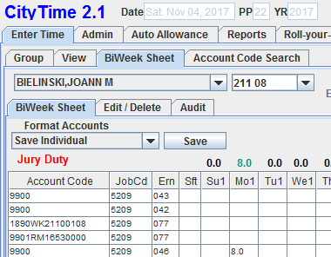
Payroll Administration requires no paperwork or adjustments to be completed for employees that serve jury duty. However, departments should be receiving the employee’s copy of jury service and completed jury duty form to keep on file and provide proof of serving jury duty.
- Military
General or Sworn Police employees are carried as earn code 047, paid military training leave, on their timecard. They are limited to 80 hours when segmented (10 calendar days including Sat., Sun. and holidays) or 88 hours in a single period (15 successive calendar days including Sat., Sun. or holidays), respectively. Sworn Fire are limited to 120 hours of 047 time. 047 may be used on the actual training days, not for travel to and from destinations, and must follow an employee’s normal work schedule.
Each department should have a work rule that mandates an employee turn in an application for military pay with orders.
If an employee claims veteran status, it is recommended a copy of his/her DD214 is kept in his/her personnel file. Once a DD214 is placed on file, HCM, personal information/regional shall be updated for the employee's veteran status. A note in general comments is always a good practice.
Long-Term, unpaid military leaves shall use earn code MLP. Instructions for unpaid military leaves may be found on the Payroll Administration website. The file is called “Unpaid Military Leave Instructions”. MLP gives pension, vacation, and sick leave credits, however provides no pay.
- Address Changes
Address changes need to be input asap. If you have employees use self-service for address changes, double check those addresses asap. Pay is dependent on where an employee resides. All employees must file the “Residence Statement Form” (#50) at the time of hire or within 72 hours of a move.
In HCM, addresses must be in all CAPS with no punctuation (123 N MAIN ST Or 453 E ANYWHERE AVE). All employees need a physical “HOME” address on file, but may have a P.O. Box as a mailing address.
Keep up on current, terminated employees addresses. Remind them when they leave to keep us updated on a new address for the next year for year-end W-2 statements. Retros and W-2's are still being processed for many.

- Garnishments, Child Support, Tax Levies
All garnishment paperwork should be sent to Payroll Administration. All garnishment calls should be directed to the garnishment hotline at 286-2492. Do not attempt to answer garnishment questions. All garnishments are processed by order of the local court, County, State, Child Support, or Taxing Authority under the rules set forth in State and Federal laws.
- Death of an active Employee
When an active employee dies, special procedures must be followed so that the employee’s next of kin is paid correctly, timely and completely. When in doubt, please call Payroll Administration with questions.
Input entry for a deceased employee needs to be made asap in HRMS on the Job Data page; use the day after the verified date of death for this entry.
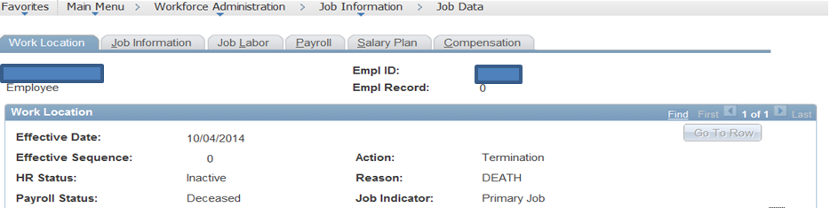
The job data entry also generates the actual date of death in the field on the page shown below; please verify.
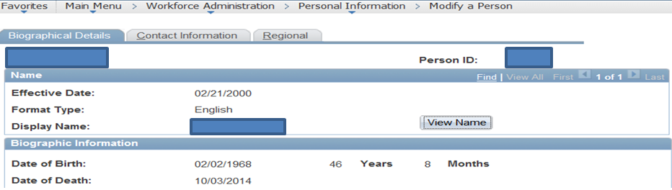
This job data entry creates a workflow process notifying Employee Benefits, Deferred Compensation, ERS, and Comptroller’s Office via email. This workflow email will have an attachment, Form C-402, Notification of Death of Employee, to be used by these departments to cancel deductions and select taxes.
The form must also be completed by the departmental payroll personnel and sent to Payroll Administration. Please make every effort to provide next of kin information on the form. Make every effort to pay all leave balances due with the last check.
Note: It is the payroll assistant’s duty to notify next of kin that the deceased employee’s check is available for pick up in the Treasurer’s Office on payday. When calling the next of kin, assure you detail the location of the Treasurer’s Office (200 E Wells, Room 103), the hours (currently 8:15am to 4:30pm) and what paperwork the next of kin should bring in. Please call Treasurer’s X3653 for questions regarding pick up procedures and requirements.
Do not fill in the Social Security number on the form. It is suppressed for security.
- Paid Time Off, the Time Owed and Allowed Report, and Employee Self-Service Leave Balance
Paid Time Off is accrued at certain rates or given at certain times of the year. Paid Time Off such as sick leave, vacation, TVA, compensatory time, holiday, time off for doctor’s appointments (069), time off for donating blood at a City-sponsored event (070), funeral leave, jury duty, military, injury pay, SLCIP etc. are defined in Chapter 350. This ordinance includes requirements for usage, rates and balance limitations.
When inputting paid time off on a timecard, please reference the Group tab for eligible earn codes.
Note: If employees are exception in HRMS and are in the ‘COM’ holiday schedule, you do not need to enter them for their holiday time. The system will do that for them.
Every Department should run the Time Owed and Allowed Report. Here’s the path in HRMS:
Enter a Run Control ID (you can use anything, like your initials). Enter or add. Choose your 4 digit deptid. Click the Run button. Click the OK button on the next page. Go to Process Monitor. When the report you ran says success/posted, click on “Details”. Click on “View Log/Trace”. Click on the PDF. This report shows vacation, TVA, sick, SLCIP and compensatory time earned and taken for your Department. It also shows injury time used.
Every Department should also run the Other Earnings Report. Here is the path in HRMS:
Enter a Run Control ID and then insert the applicable pay run ID. Click the Run button. Click the OK button on the next page. Go to Process Monitor. When the report you ran says success/posted, click on “Details”. Click on “View Log/Trace”. Click on the PDF. This report shows Misc time (069), Paid Military Leave, Union Activities, Holiday and Jury Duty.
These reports are ready on the Monday of payweek. These reports should be reviewed to assure all time taken off was subtracted, all time earned was added and that the balances look appropriate for all your employees. Paid time off is also displayed at the bottom of each timecard. If employees do not enter their own time on their timecards, then the TOA needs be shared with employees. This report is copied over pay period after pay period. It is recommended that you run the TOA and General City Other Earns reports during payweek and save or print it. After payweek, the report for a previous pay period will not be available.
Remind employees that they may review their paid time off balances in Self-Service. They may go to:
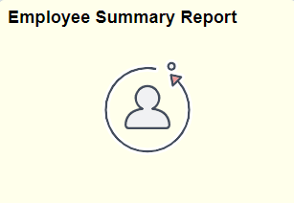
Scroll down to Leave balances.
It is the joint responsibility of the employee and payroll clerk to assure time is correct and that it is taken within the parameters defined in Chapter 350.

- Payroll Register
Every Department should run the Payroll Register. Here is the path in HRMS:
Enter a Run Control ID and then insert the applicable pay run ID and the four-digit dept ID. Click the Run button. Click the OK button on the next page. Go to Process Monitor. When the report you ran says success/posted, click on “Details”. Click on “View Log/Trace”. Click on the PDF.
This report should be reviewed for accuracy. This report is available on the Monday of payweek. You don’t need to save or print, as the reports are always available.
- Detail Dollars and Hours
Every Department should run the Detail Dollars and Hours Report. Here is the path in FMIS:
The report should be reviewed for accuracy. This report is available on the Monday of payweek. You don’t need to save or print, as the reports are always available. RITS request should be submitted when the report is not available. Payroll Admin does not post this report.

- Auto Allowance
It is the responsibility of employees and their managers to assure auto allowance is entered monthly. Employees should not be waiting for months to submit their mileage. Please make sure your employees are making these submissions timely every month.
Auto allowance is defined in Chapter 350. Mileage of a 1,000 miles or more needs special approval from F & P. Auto allowance is due 30 days after the end of the month. Monthly auto allowance is entered in Citytime on the Auto Allowance Tab.
While every employee that has access to Citytime has access to Auto Allowance, Payroll Administration sets up approvers for Auto Allowance. The form may be found in the Payroll Administration website, located on the Payroll Administration website. The file is called “Access Form for Auto Allowance”. The form must be signed by a Department Head (or designee). The signed form may be scanned/e-mailed or interoffice mailed to Payroll Administration.
There are instructions for auto allowance located on the Payroll Administration website. The file is called “Instructions-Auto Allowance-Rev 03-2015”. You may share this with the employees that claim auto allowance.
Entries must be manager approved by 11:00am on payday. Auto allowance share the same due date as adjustments.

- Commuting Mileage (not AUTOMOBILE ALLOWANCE)
Chapter 350 defines commuting mileage as “The use of a city-owned vehicle from the home or place of residence to the place of work and from the place of work to the home or place of residence and all other mileage not within the usual, regular, or customary duties of the official or employee affected shall be deemed personal mileage.” Commuting mileage is taxable to the employee.
The City uses the Internal Revenue Service (IRS) Commuting Valuation Method to value an employee’s personal commuting use of an employer-provided vehicle. The employee is taxed on the value of a daily, round-trip commute when using a City vehicle and must submit form CBP-194R (City of Milwaukee Biweekly Commuting Miles) biweekly to their Department head for signature. These forms are then forwarded to the Comptroller’s Office. Please note there are some exceptions for employees who are assigned vehicles unlikely to be used for personal travel because of design (i.e. police car). In these cases the use of the vehicle by an employee may be excluded from income. For more information see the following IRS Publication 15-B (Employer’s Tax Guide to Fringe Benefits).
The form may be found in FORMS. It is called Biweekly Commuting Miles, City of Milwaukee, form CBP-194R

- SLCIP (Sick Leave Control Incentive Program)

SLCIP is a program that encourages the responsible use of sick time, is administered by trimester, and is best defined in Chapter 350. Chapter 350 defines who is eligible, how it is paid, and when the SLCIP time must be used by.

Note: For all General City employees, SLCIP time posted in a fiscal year must be used by the end of that fiscal year or lose all rights to it. Local 215, fire, has different rules.
Payroll Administration will send to all payroll managers/assistants a memo with instructions at the end of each trimester. It is important that these instructions are followed so that employees get the time off or pay that they have earned in a timely manner.
The earn codes used to administer SLCIP are as follows:
SIA on the TOA adjustment tab (in the adjustments) gives the employee a day off on the TOA
064 on the Hours adjustment tab gives the employee a day of pay.

063 is on the Dollars adjustment tab. This buys out an employee’s SLCIP balance if they leave service with the City.

062 is used on a timecard when someone takes a SLCIP day off.

The Trimesters for eligibility are:
1-9 – Trimester 1
10-18 – Trimester 2
19-26 or 27 – Trimester 3

- Pension
Employee’s Retirement System administers all pensions like ERS and WRS (Wisconsin Retirement System, effective 01/01/2024 for all new hires). All employees that have questions regarding their pension accounts or eligibility should be directed to 286-3557 or the ERS website.
ERS - Eligible employees are credited with up to 80 earnable hours (106 for fire) per pay period toward their pension. Earnable hours do not include premium overtime. Certain dollar amounts like shift and weekend differentials are also credited toward an employee’s pension.
WRS – All income (except mileage reimbursements) is subject to a pre-tax deduction for WRS EE contributions.
All employees contribute to his/her own pension account. The amounts vary depending on a variety of reasons up to and including date of hire, contract language or ordinal language. Please refer to Chapter 36 for details.
ERS - The retirement age of general city employees is age 60 (or age 55 with 30 years of service) if hired prior to January 1, 2014. If hired January 1, 2014 or after, the retirement age is age 65 (or age 60 with 30 years of service). This means that terminal leave will not be considered unless the employee has met these criteria. Sworn police and fire employees have their own sets of rules. Please refer to Chapter 350-38 regarding terminal leave.
WRS – retirement ages to be determined at the time of this update.
- Donor Pay
Most employees may participate in the donor program, provided they meet program criteria. Most employees may donate time to an eligible participant. Please refer to Chapter 350-45 for program details.
Here are the steps in the donor program:
- Employee applies and then becomes eligible to receive donations – through DER.
- Donors (other employees) may donate eligible time using the form titled “Notification of intent to donate time”.
- Form is approved by DER.
- Payroll Clerk will prepare the donation adjustment-
When preparing donation adjustments on the TOA tab, please place the word “donate” in the description.
This example is Joann donating 8 hours of comp time to Bernie Brewer. It could be vacation or holiday for sworn only. (VCA and HLA are the TOA codes for an adjustment). Assure the employee has the time to donate.
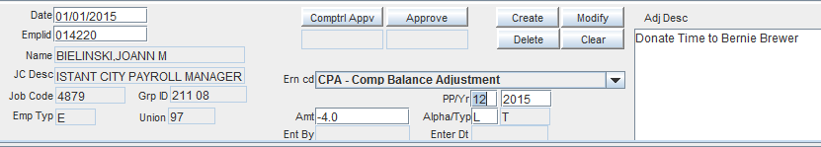
- When an eligible employee uses donated time, earn code 943 must be placed on the timecard.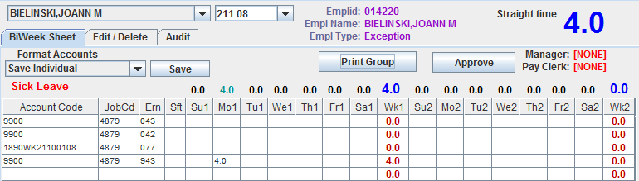
Bernie Brewer
7. Participant Employee must use accumulated TVA, vacation, comp and sick leave prior to utilizing donor time.
- There are two reports in the Citytime Reports dropdown that track donor.
Donor Balance for Emplid. Have an employee’s 6 digit employee ID available. Enter it at the prompt. If you are a manager or payroll clerk that is authorized to see that employee’s donor balance, it will display the current balance. New donations are posted by Pay Admin by pay week Fridays, based on all entries made in #4. All donor pay balance and usage questions should be directed to pay adm (ptransmit@milwaukee.gov)

This report will show all entries PP8, 2024 forward. Pay Admin posted PP7, 2024 donor participant balances and subsequent donations to earn code DON in Citytime. DON is an earn code that summarizes all donations to one employee record. It is included in the balance. Earn code 943 takes away from the balance. All detail in this report is recognized in the employees Donor Balance. If you believe it exists and is not listed, contact pay adm e-mail.

- Pay Run ID
The pay run ID is the 2 digit year and the PP letter. PP20, 2019’s Pay Run ID is 19T. PP26, 2019 would be 19Z. PP3, 2024 would be 24C

- Advances
The Payroll Advance Request, Form CBP-100, is available from Payroll Administration. This form may be used to advance employees emergency cash, prior to payday, or to correct catastrophic errors.
Advances are considered on a case-by-case basis. Only in dire emergencies may an advance request be considered. Cash advances for late payments on bills or cash for vacations will not be approved. An employee may receive up to 60% of last pay period’s gross or the net pay of the previous pay period, whichever is lower. The advance must be signed by the Department Head.
If a catastrophic error is discovered prior to payday, for instance, an employee’s hours were not entered and he is not receiving an expected check, the City will give the difference to the employee, via ACH or cash, up to 60% of the last check. If a large deduction was taken when it should not have been, the City will refund the deduction in cash. Cash for errors will be given on payday, no sooner. The advance must be signed by the Department Head. Adjustment for the time missed or the deduction taken must be made on the next check.
If the employee can wait until the errors are corrected on the next paycheck, please encourage them to wait.

- Overpayments/Underpayments
If an employee was overpaid, attempts to collect this money must be made. It is best to discuss the overpayment with the employee. It is encouraged to take as much as you can without dropping the employee below the minimum wage. Employee permission is not necessary.
If an employee was underpaid, an adjustment to rectify this situation should be made as soon as administratively practicable. For catastrophic underpayments, an advance may be considered (see previous section). When preparing adjustments for underpayments, due diligence in selecting an event date must be used.
- Overtime
The Fair Labor Standards Act, State Statutes, Chapter 350-1 and Contracts details how and when overtime must be compensated. When the City pays overtime in cash, the most common earn codes of 081 and FLS are used. When the City pays overtime in comp, earn code 086 is used.
When a nonexempt, General City employee works more than 40 hours in a Sunday through Saturday work week, all time must be entered as earn code 077. The system will calculate overtime premiums and pay under earn code FLS.
Earn code 086 gives employees compensatory time at time and one half of the hours worked. General City employees may use this code after reaching 40 hours of work and/or holiday in a Sunday through Saturday workweek. A Department’s rules must authorize employees to claim overtime as compensatory time. All employees are limited in the amount of compensatory time they may carry on the Time Owed and Allowed.
For nonexempt, General City employees working on a city-recognized holiday or furlough, any time worked must be claimed as 081 (if desiring cash) or 086 (if desiring comp time). This will automatically compensate employees at time and one half, as outlined in Chapter 350-1. If the nonexempt, General City employee is in a position that does not get a paid holiday, they should still be compensated with 081 or 086 for hours worked on the holiday.
Employees exempt from overtime must adhere to Chapter 350-5 (4) (5) . Buyouts must occur immediately. A two-part adjustment needs to occur. B66 for the hours to the last active date for an employee.
Earn code FLS is system generated. Please refer to the FLSA Class manual for specific examples. FLSA Class manual goes into detail regarding the very complicated FLSA calcs for Police.

- NDB (Non-Discretionary Bonus)
The Non-Discretionary Bonus Payment is generated in PP#8 of each year. This payment is the result of boosting eligible FLS pay by Non-discretionary Bonuses.
The most recognizable NDB is uniform allowance. Other NDB are SLCIP, Longevity, VSAP, and other sworn bonuses.
The formula for NDB’s is:
((NDB Dollars/Total FLSA Hours)/2)=NDB FLSA Rate
NDB FLSA Rate*FLSA OT Hours = NDB Payment

- Clearing your cache

It is always a good idea to clear your history every now and again. It helps HCM perform at its most optimal level. It also might resolve issues with sites not loading, loading slowly, etc. Always clear your cache for one of the first steps in resolving issues with HCM and city sites.

- Where to find things and Conclusion
Feel free to forward employees to these notable phone numbers:
Worker's Compensation 286-2020
Deferred Compensation 844-360-MDCP (844-360-6327)
Employee's Retirement System 286-3557
Employee Benefits 286-3184
Sites referenced:
Payroll Administration’s website:
https://city.milwaukee.gov/Comptroller/PayrollAdministration

Salary Ordinance and Chapter 350:
https://city.milwaukee.gov/cityclerk/LRB/ordinances/tableofcontents

Forms:
https://city.milwaukee.gov/DER/PoliciesProcedures/Forms

Citytime:
https://citytime.milwaukee.gov/

Department of Employee Relations Policies:
https://city.milwaukee.gov/DER/PoliciesProcedures/Policies

Payroll Administration is comprised of the following:

Joann Bielinski - City Payroll Manager - x2967
Casey Kloss – City Payroll Assistant Manager - x2312
Terri Spidell – City Payroll Specialist Lead – x2320
Theresa Schaewe – City Payroll Specialist – x2310
Catina Peters - City Payroll Specialist - x2313
Lisa Garza – City Payroll Specialist – x2963
Lori Hoffman – Time Tracking Lead – x2829

Garnishment Hotline – x2492

Do not hesitate to call us with questions.

This manual is not meant to replace any policy, ordinance or rule. This manual is meant as a helpful guide to all payroll assistants and managers.

Please report broken links to Joann Bielinski. Think we should add another section? Let Joann Bielinski know that as well.

Original publish date 07/2015
Revision date 09/2026

