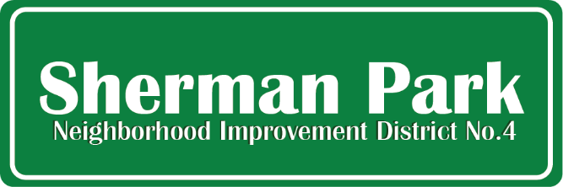

Notice of Board Meeting

Jeannie Berry-Matos, Deborah Black, Alleace Fleming, Tristan Hickman,
Jack Jenkins, Jacquelyn Rice, Kiante Shields, Shannon Snow
Mabel Lamb, Ana Branderhorst

Monday, Oct 12th, 2026, 6:30 PM
SPCA Annex, 3524 W Fond Du Lac Ave

Agenda

- Review July meetings minutes
- Elect board secretary
- Review Repayment MOU
- NID Project Presentation
- Financial Report
- Next board meeting Monday, Jan 11, 2027 via Zoom at 6:30 pm

Ana Branderhorst will follow up with a calendar invite.

