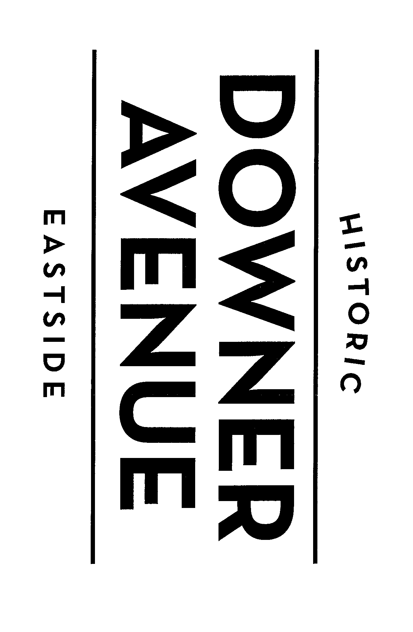

MEETING AGENDA
Business Improvement District Board of Directors Meeting
Wednesday, July 22, 2026, 8:30am
Topic: Monthly BID Board Meeting
Canela Café (2621 N. Downer Avenue)

- Call to order
- Approve May 2026 Minutes
- 2026 Budget Update and P&L
  - Social Media Expense
  - Air & Water Show Sponsorship
- BID 2026 Fee Assessment
- Events
  - 47th Café Hollander Otto Wenz Downer Classic – Recap
  - Downer Avenue Haunted Halloween – 10/17/26
  - Tree Lighting – TBD 12/4 or 12/12
  - BID Holiday Party – 12/9 or 12/10
- Beautification/Traffic Calming/Safety
  - Tree Proposal, Planter Move ($1,000)
  - Additional Pedestrian Signs
- Open Issues/Discussion
- Adjournment

Dated July 16, 2026
Should you have any questions or comments regarding any items on this agenda, please contact the Historic Downer Avenue BID Director Janet Henning at historicdowneravenue@gmail.com. Upon reasonable notice, efforts will be made to accommodate the needs of individuals with disabilities.

